CSC3320 System Level Programming

Lab Assignment 4 - Part 1 (In- Lab)

Instructor: Fil Rondel

Purpose: Practices on the grep family commands to process texts in files.

Note: Please follow the instructions below, and write a report by answering the questions and upload the report (named as Lab4_P1_FirstNameLastName.pdf or 

Lab4_P1_FirstNameLastName.doc) to Google Classroom.

Please add the lab assignment NUMBER and your NAME at the top of your file sheet.

Open your terminal and connect to snowball server. Change your directory to your home directory (cd ~ ), and then create a new directory named as “Lab4” (mkdir Lab4). After that, go to directory Lab4 (cd Lab4) and please download the file "CSC_Course.txt" by the following command (internet access required):

cp /home/frondel/Public/CSC_Course.txt CSC_Course.txt Be sure it succeeds using “ls” to see the file name “CSC_Course.txt” listed.

Try the following commands step by step and finish the required tasks from step 4) to step 16).

Note: marks a single space.

1) $more CSC_Course.txt

Check the content of "CSC_Course.txt" using more.

Note: When viewing the file, you may need to use command f (forward one screen), b (backward one screen) and q(quit).

2) $grep 'CSC 3320' CSC_Course.txt

Note: there is a single space between "CSC" and "3320" Output the lines containing the string "CSC 3320"(search the course the number of which is "CSC 3320")

3) $grep -i 'CSC 3320' CSC_Course.txt

Output the lines containing the string "CSC 3320" via ignoring case (search the information related to CSC3320)

4) $grep 'CSC 3' CSC_Course.txt

Attach a screenshot of the output and describe what this commanddoes

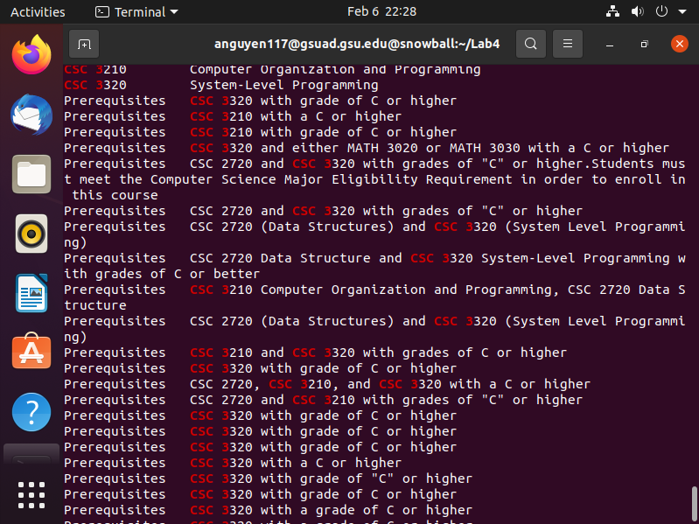

This commands finds and list any lines containing the string “CSC 3”.

5) $ grep 'CSC 3|CSC 1' CSC_Course.txt

Attach a screenshot of the output and describe what this command does.



Command does either nothing or gave no output.

6) $ grep -E 'CSC 3|CSC 1' CSC_Course.txt

Attach a screenshot of the output and describe what this command does. Use extend regular expression

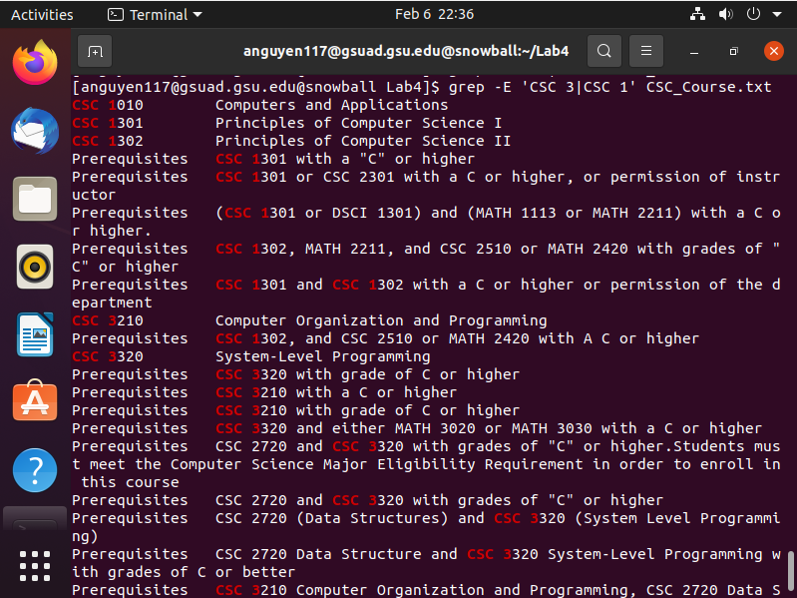

Finds strings that is either containing “CSC 1” or “CSC 3” and output the lines that contains them.

(CSC 1)|(CSC 3)

7) $ egrep 'CSC 3|CSC 1' CSC_Course.txt

Attach a screenshot of the output and describe what this command does.

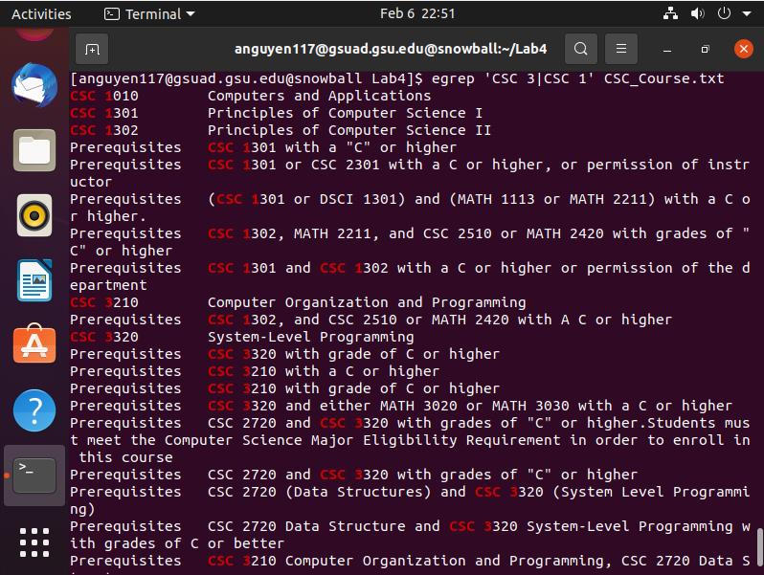

It is seemingly the same as 6) where it finds the string that contain CSC 1 or CSC 3 and lists the lines that have them.

8) $ fgrep '3.000 Credit hours' CSC_Course.txt Attach a screenshot of the output and describe what this command does.



Command does seemingly nothing.

9) $ fgrep -x '3.000 Credit hours' CSC_Course.txt Attach a screenshot of the output and describe what this command does. Only match the whole line



The command does seemingly nothing visually.

10) $ grep 'CSC.*Programming' CSC_Course.txt Attach a screenshot of the output and describe what this command does.

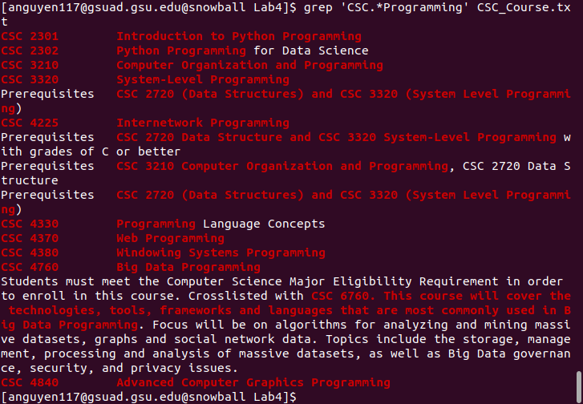

The command searches for the string in the beginning “CSC” and allows characters after it for 0 or more times in be included in the search as long the word Programming is found at the end.

11) $ grep '^CSC.*Programming$' CSC_Course.txt Attach a screenshot of the output and describe what this command does.

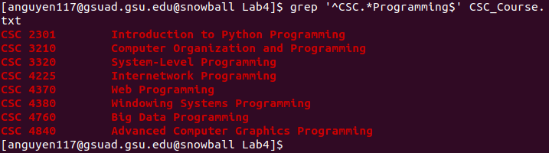

It searches for the beginning string of “CSC” and allows any number of characters afterwards as long as the string “Programming” is at the end. Unlike 10) , if the line does not purely contain the searched parameter, the line is not outputted.

12) $ grep --color 'CSC[^3]*3{2}' CSC_Course.txt Attach a screenshot of the output and describe what this command does. No result, {} is not a special character



The command seemingly gives no results.

13) $ egrep --color -w 'CSC[^3]*3{2}[^3]*' CSC_Course.txt Attach a screenshot of the output and describe what this command does. -w Select only those lines containing matches that form whole words.

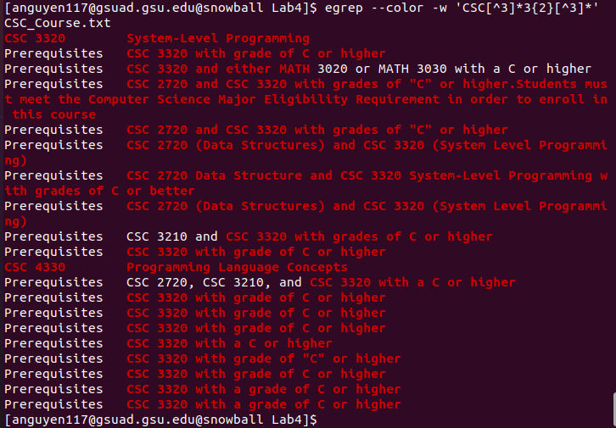

It first matches by the string “CSC”. It only allows matches with an entire word after CSC and the number. It does not match numbers after any string that is not “CSC”.

14) $ grep 'CSC.*C++' CSC_Course.txt

Attach a screenshot of the output and describe what this command does. + is not a special character in basic regular expression



This command does seemingly nothing or generated no results to output. Maybe there is nothing that starts with CSC and ends with C++ to find in search?

15) $ egrep 'CSC.*C\+\+' CSC_Course.txt

Attach a screenshot of the output and describe what this command does. Convert +



It seemingly does not generate a result to output or does nothing.

16) $ egrep 'CSC.*C++' CSC_Course.txt

Please only describe what this command does.

This command finds the beginning string “CSC” and matches any characters afterwards until the character ending is the very last “C” and outputs the lines that contain this pattern.

2

Optional Part:

1) $ sed -E -n 's/(CSC 3[0-9]{3})(.*)/\1/p' CSC_Course.txt Attach a screenshot of the output and describe what this command does.

2) $ awk -F'-' '/(CSC 3[0-9]{3})(.*)/{print $1}' CSC_Course.txtAttach a screenshot of the output and describe what this command does.

3) $ sed -E -n 's/(CSC [0-9]{4})( - )(.*)/\3/p' CSC_Course.txt Attach a screenshot of the output and describe what this command does.

4) $ sed -E -n 's/(CSC [0-9]{4})( - )(.*)/\3/p' CSC_Course.txt| sort

Attach a screenshot of the output and describe what this command does. 3